ASSEMBLIES OF GOD
CHAPLAINCY
Ministry of Jim & Julie Uhey * 831.713.8826 * www.tppusa.org * 865 Monterey Avenue, Apt. K * Capitola, California * 95010
U.S. Missions Account # 700001 2295699 (00) * 1445 N. Boonville Avenue * Springfield, Missouri * 65802

Ministry Update

January was filled with meetings that Jim either chaired or participated in – Santa Cruz County VOAD; NorCal VOAD; Honor Bound Men’s Ministries, and our quarterly Phoenix Project USA Board meeting.

In February, Jim traveled with our NorCal/Nev (NCN) District Officers, Department Leadership, and fellow Missionaries, as part of the yearly Superintendent’s Tour. In a two week period Jim put 3,000 miles on our “new” car as he met with Pastors whose churches have sponsored training events, and partners that provided supplies during the NCN district’s response to fires in 2017, discussed the setting up of regional warehouses to be used in future disasters, and spoke at First Assembly of God, Auburn, CA.

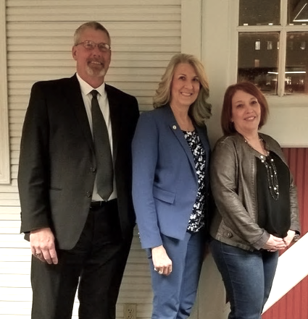
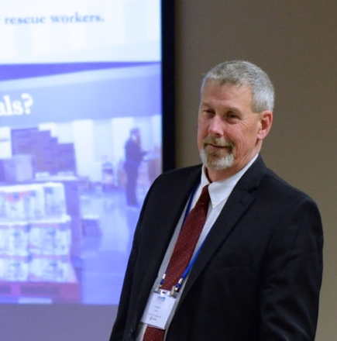
EXECUTIVE ACADEMY UPDATE
At Cathy Clark’s invitation, Jim flew to Minneapolis, MN, to present a breakout session, “Disaster and Crisis Recovery – Restoring the Local Community Through Collaborative Efforts”, at the Governor’s Conference, for Homeland Security and Emergency Management. Cathy is with the State of Minnesota Public Safety. Dr. Carol Cwiak is an Associate Professor at North Dakota State University, and Executive Director of the Emergency Management Higher Ed. Consortium. Dr. Cwiak has approached Jim, and FEMA, about Jim becoming an instructor with FEMA in the future.

Jim Presenting in Minnesota Jim, Cathy Clark & Carol Cwiak

Devante, Stacie, Malachi, Julianna, Danielle, Marcos Joanna & Stephen
FAMILY UPDATE
Our Daughter & Her Family:
Stacie is enjoying her new job working as a Social Service Aide with Humboldt County, and Marcos continues to do amazing work at the Betty Chinn Day Center. Julianna will graduate from high school in June! Danielle and Malachi continue to excel in school, and Devante is living & working in San Jose. We are so proud of all of them!

Our Son
Stephen and Joanna got engaged in December! Their wedding will be in June of 2019, in the Santa Cruz area. In April Joanna flew back to Berlin, Germany, to finish her year of study, and Stephen left to spend the next 5 months in New York painting murals with Thrive Collective for their upcoming season. So happy for both of them!

Devante, Stacie, Malachi, Julianna, Danielle, Marcos

