ASSEMBLIES OF GOD
CHAPLAINCY
Ministry of Jim & Julie Uhey * 831.713.8826 * www.tppusa.org * 865 Monterey Avenue # K * Capitola, California * 95010
U.S. Missions Account # 700001 2295699 (00) * 1445 N. Boonville Avenue * Springfield, Missouri * 65802

November and December - Update
The last 3 months have been really busy for Jim. A week in Las Vegas following the mass shooting working with Pastors and Churches. Working with Pastors and Churches responding to the fires in Northern California as they provided ministry as well as supplies to evacuees.

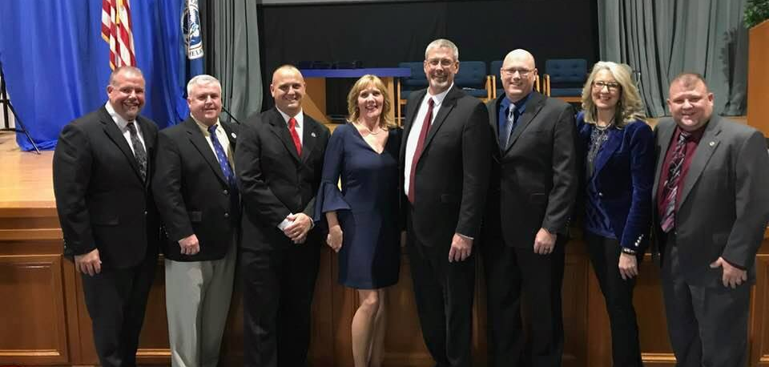
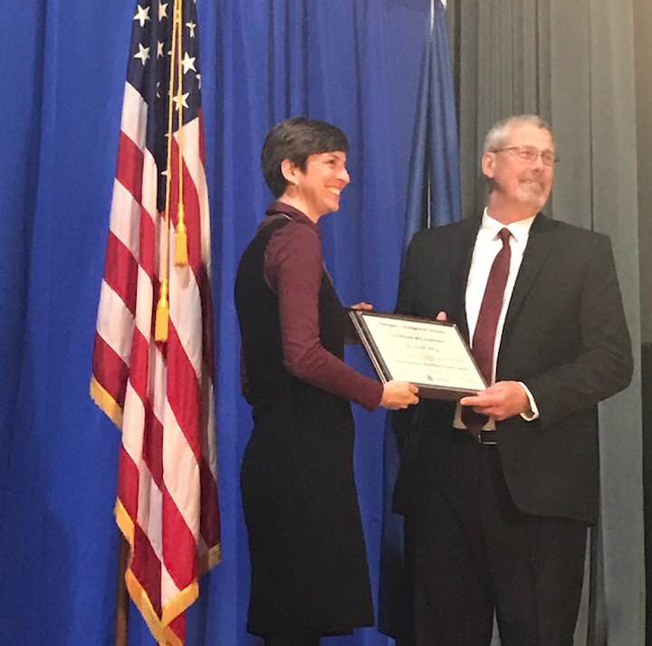
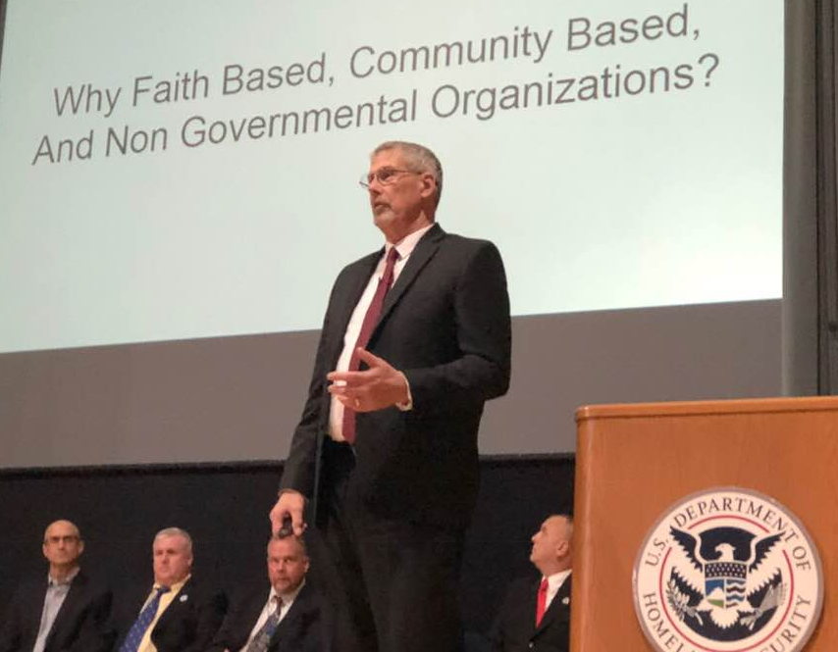
One of our board members, Greg Crabtree, who also serves on the Church Board for New Life Center in Novato worked with numerous groups to set up a warehouse that could receive and deliver supplies throughout Sonoma and Napa Counties as well as other isolated areas. Jim and Greg worked with Convoy of Hope, Assist International and Good360 to meet specific requests that have come their way.

In December, Jim graduated from FEMA’s Emergency Management Institutes’ Executive Academy. Throughout the year, Jim has built relationships with Emergency Managers from across the county. It has been a very fulfilling time for Jim as he learns and networks with others of like passions.

Joanna and Stephen Stacie, Marcos and ALL the kiddos
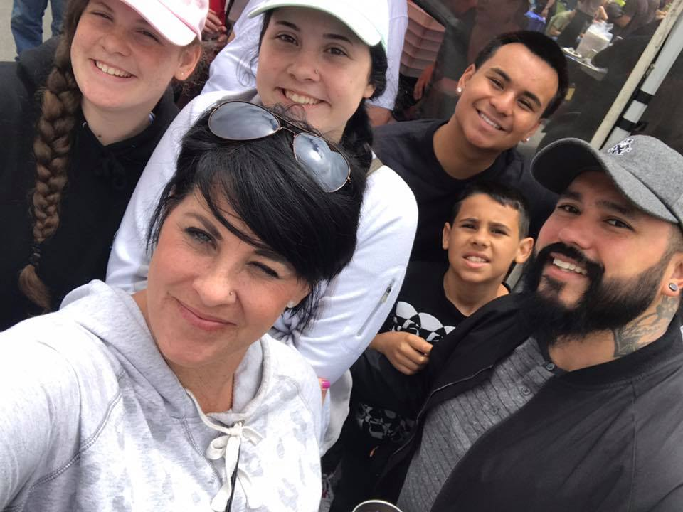
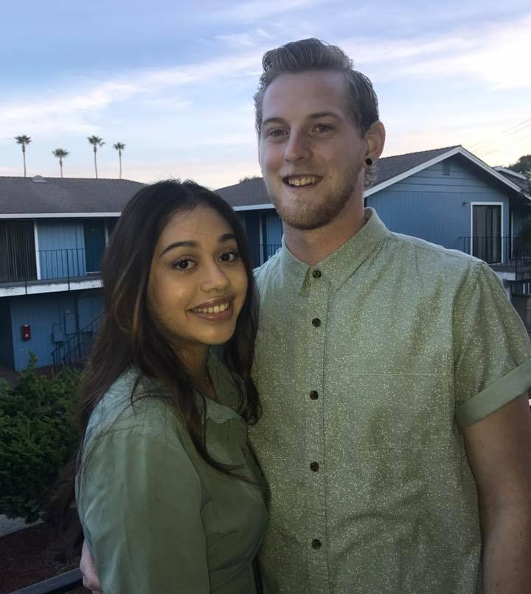
Stephen spent the summer in New York working for Thrive Collective and Joanna worked in Colorado at a Summer Camp. They then flew together to Spain and Germany with Joanna’s dad. She is spending the year in Berlin at Berlin University.

Stephen is in Eureka working at an Art Store and has joined Marcos and Stacie working at the Betty Chinn Day
Day Center. Marcos is the Day Center Manager while Stacie and Stephen have worked at the transitional housing for families. Julie and I were blessed to be a part of Betty’s Thanksgiving outreach.
WE ARE THANKFUL FOR . . .

God, family, friends, and our leadership …
National U. S. Missions Leadership Team:
New Executive Director: Rev. Malcolm Burleigh, Administrator: Ramona R. Edgman, Chaplaincy: Rev. Manuel Cordero

Northern California/Nevada Leadership Team:
Superintendent: Rev. Bret Allen, Assistant Superintendent: Rev. Samuel Huddleston, Secretary-Treasurer: Rev. Jay Herndon

Our Phoenix Project Board: Rev. Will Nelken, Ray Jones and Greg Crabtree

Individuals that support us monthly …
Kevin & Shari Allen, Dolores Anderson, Rev. David & Sheryl Auterson, Carol Besserman, Rev. Bob & Linda Bridges, Gen Cannizzaro, Gregory & Giovanna Crabtree, Clara Flores, Rev. Marsha L. Gipson, Rev. Jay & Teri Herndon, Larry & Marlene Holtzclaw, Annette Howell, Jerry & Rev. Deborah Huber, Rev. Jeff & JaDene Jones, Ray & Laura Jones, Gary & Anita Kalus, Rev. Darrell and Donnell Kenworthy, Nick & Dana Lazzareschi, Rev. Trevor & Jackie Lee, Avery Lewis; Elvin Luis, Everett & Lori May, Esther Mijares, Doug & Diane Morey, Brian & Linda Mulliner, Rev. Ingrid and Troy Nash, Rev. Jerry & Cherie Peters, Rev. Dale & Jan Reece, Rick & Kris Roberts, Rev. Richard and Margaret Rogers, Rosa S. Rogers, Danny & Priscilla Sanchez, Sheryl Sessions, Bob & Nancy Spalding, Marcile & Sheila Stanton, Martha Uhey, Rev. Mark and Alice Whitehead.

Individuals that have given special offerings …
Rev. Tom and Nikki Allison, Rev. Jeff Behnke, Shirley Cannon, Rev. Ron and Jill Chin, Greg and Giovanna Crabtree, Lori J Degrace, Chi & Olivia Fong, Rev. John and Jan Haak, Martha P. Hoots, Debbie LeDet, Len and Bertie Maria, Bill and Marilyn Morden, Rev. Will and Martha Nelken, Rev. Dale and Jan Reece, Rev. Mark and Alice Whitehead, Maury A. Wilkinson, Rev. Cyndee and Larry Thomas.

Churches that support us monthly …
Abundant Life Assembly of God, Cupertino ~ Rev. Greg Wendschlag Legacy Community Church, Los Gatos ~ Rev. Chris Annas
Amador Christian Center, Plymouth ~ Rev. Danny Arroyo Lighthouse Covenant Fellowship, Benicia ~ Rev. Phillip Green
Assembly of God Full Life Christian Center, S.F. ~ Rev. Au-Yeng Mason Valley A/G, Yerrington, NV – Rev. David Hardesty
Bethel Church, Eureka ~ Rev. Willy Bowles Monterey Bac C.C., Seaside – Rev. Jason Yarbrough
Calvary Assembly of God, Milpitas ~ Rev. Mike Todd Mt. Pleasant Christian Center, San Jose ~ Rev. Matt Munoz
Calvary Assembly of God, Ely, NV ~ Rev. Keith Groben Mountain Bible Church, Los Gatos – Rev. John Haak
Church of the Cross, Hayward ~ Rev. Brian Gering New Beginnings, Los Banos ~ Rev. Ron Bailey
Coast Community Chapel, Capitola ~ Rev. Scott Tuttle New Hope Community Church, Gilroy ~ Rev. MacPhail
Community Assembly of God, San Francisco ~ Rev. Barbara Cornejo New Hope Community Church A/G, S. SF – Rev. John Withers
Community Family Worship Center, Modesto ~ Rev. Steve Lebsack New Life Christian Center, Reno – Rev. Angelo Austira
Cutten Community Church, Eureka – Rev. Bill Johnston New Life Center, Rancho Cordova – Rev. David McFarland
Evangel Assembly of God, Visalia ~ Rev. Lee Reynolds Park Slope Christian Tabernacle, Brooklyn ~ Rev. Luis Alvarez
Faith Assembly of God of Stockton ~ Rev. James Menchaca Real Life Church, Sacramento ~ Rev. Dean Degura
Family Life Christian Center, San Jose ~ Rev. Mitch Thurman Rise City Church, Redwood City – Rev. Derik Scott
First Assembly of God, Amory, MS ~ Rev. Justin Myers Ruby Mountain Chapel, Wells, NV – Rev. Artie Lookingbill
First Assembly of God, Marina ~ John Worthy Ruth Community Church, Ruth, CA – Rev. Todd Heaton
Gathering by the Bay, Soquel – Rev. Dave Gschwend Shorelife Community Church, Capitola ~ Rev. Trevor Lee
Green Valley Christian Center – Rev. Gary Morefield Sunnyslope Christian Center, Hollister – Rev. Kevin Townsend
Harvest Time Assembly of God, Brentwood ~ Rev. Dennis Reynolds Sunnyvale International Church ~ Rev. Jorge Marsal
Hidden Valley Community Church, Middletown ~ Rev. Zach Pyzer The Journey, Rio Dell ~ Rev. Jeff Miller
Hillside Church, Redding ~ Rev. Darrell Farley Trinity Church, Escalon ~ Rev. Jim Davis
Horizon Christian Fellowship, West Sac. ~ Rev. Coco Perez Trinity Community Church, San Rafael – Rev. Will Nelken
Trinity Life Center, Las Vegas, NV ~ Rev. Randy Greer

Churches & Groups that have given special offerings and/or honorariums …
Bethel Assembly of God, Portland, OR – Rev. Gary Russell NCN District Office – Rev. Bret Allen, Superintendent
Children’s Ministries, NCN District – Rev. Nikki Rogers New Beginning Church, Los Banos ~ Rev. Ron Bailey
Church of the Cross, Hayward ~ Rev. Brian Gering New Life Center, Rancho Cordova ~ Rev.David McFarland
Coast Community Chapel, Capitola ~ Rev. Scott Tuttle Parkslope Christian Tabernacle – Rev. Luis Alvarez
Crossroads Fellowship A/G, Newcastle – Rev. Steve White Real Life Church, Sacramento – Rev. Dean Degura
Cutten Community Church, Eureka, - Rev. Bill Johnston Ruby Mountain Chapel, Wells, NV. Rev. Artie Lookingbill
Family Life Christian Center, San Jose – Rev Mitch Thurman Shorelife Community Church, Capitola ~ Rev. Trevor Lee
Full Gospel Church, King City – Rev. David Irwin Sunnyslope Christian Center, Hollister – Rev. Kevin Townsend
Gateway Community Church – Rev. Mark Whitehead Sunset Bible Assembly of God, S.F. – Rev. Kenny Rogers
Hillside Christian Center, Napa – Rev. Eric Daniel Trinity Church, Escalon – Rev. Jim Davis
Monterey Bay Christian Center, Seaside – Rev. Jason Yarbrough Trinity Community Church, San Rafael ~ Rev. Will Nelken
Mountain Bible Church, Los Gatos ~ Rev. John Haak Trinity Life Center, Las Vegas, NV – Rev. Randy Greer

Extras …Doug Duncan ~ for legal advice and work on behalf of our ministry; Rev. Tim and Ginger Hohm and Mojo Video for producing our videos; Ray Jones for keeping us supplied with his delicious barbeque sauce; Dean Moon ~ tax man extraordinaire; Cecil Wong who serves as Jim’s ministry coach; New Life Center in Rancho Cordova for lots of free housing; Shorelife Community Church for free office space and internet, DDS Rick and Renee Smith ~ for giving our family winning smiles.
All of you who pray for us on a regular basis … We pray for you, too!

